**10 Awesome APIs for Every Web Developer in 2022 -** [Mehdi Aoussiad](https://mehdiouss.medium.com/?source=post_page-----be1a7acb73ad--------------------------------) Jul 22, 2022

A list of extremely useful APIs that you can use for your next web projects.

Nowadays, APIs are everywhere and they are extremely useful when it comes to web development. As a web developer, an API or what’s called an application programming interface is a great way to access specific data and interact with it in your web projects.

APIs can allow us to have communication between the frontend and backend in our applications. This is a great way to access external data and display it on our website or application.

Using APIs has a lot of advantages for you as a web developer. The good thing is that it can make your website or app more dynamic with the features that an API can give you. In addition to that, it’s also a way to save time without having to write too much code.

In this article, we will have a look at some very useful and fun APIs to use on your next projects. So let’s get right into it.

**1. Giphy API**

[Giphy API](https://developers.giphy.com/) is a very useful and awesome API that gives you access to a rich GIF and video library. The beauty about Giphy’s amazing APIs is that they allow you to supercharge and boost engagement in your application with just a few lines of code.

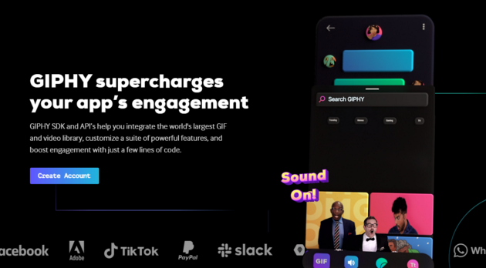

Capture by the author from GIPHY Developers.

Giphy gives you everything to make your app more engaging for the users. All that by offering an exclusive library of GIFs, stickers, and clips. In addition to that, you get access to their powerful search algorithms which will allow your users to animate their conversations with the exact GIF they’re looking for.

**2. OpenWeatherMap API**

[OpenWeatherMap](https://openweathermap.org/current) is another awesome API that allows you to access the current weather data for any location you want. In addition to that, you can also get a lot of information about the weather in that specific location you’re looking for. This API has a lot of cool features you can use.

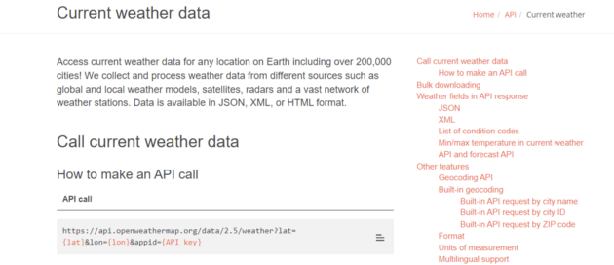

Capture by the author from OpenWeatherMap.

You can easily make API calls and you can get the data in HTML, JSON, or XML format.

**3. NASA APIs**

[NASA](https://api.nasa.gov/) comes with a list of awesome and useful APIs for software developers to use. These APIs can allow you to access a lot of NASA data about the moon, space weather, astronomy, Mars, and a lot more.

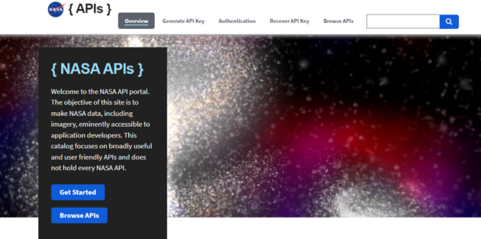

Capture by the author from NASA.

I highly recommend that you check out their documentation for more information and guides on how to use the APIs in your projects.

**4. MealDB API**

[MealDB](https://www.themealdb.com/) is another useful API if you’re looking to get access to recipes and random meal data. It gives you a lot of types of meal data such as ingredients, meal images, meal categories, videos, and a lot more.



Capture by the author from MealDB API.

**5. Frankfurter API**

[Frankfurter API](https://www.frankfurter.app/) is a very useful open-source API that allows you to get access to a lot of data about foreign exchange rates posted by the European Central Bank.

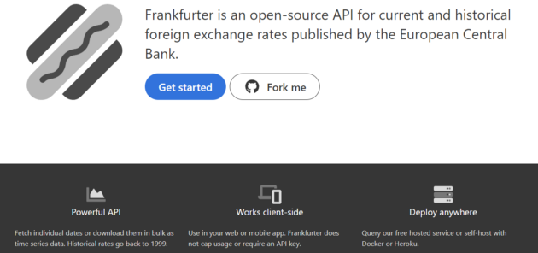

Capture by the author from Frankfurter API.

So you can easily get current and historical exchange rates, and also get or track currency data. The API doesn’t require a developer key.

**6. Random Facts API**

This amazing [API](https://www.programmableweb.com/api/random-useless-facts) allows you to get access to a lot of random facts and use them in your projects. You can get random facts in JSON, HTML, MD, and TXT format.

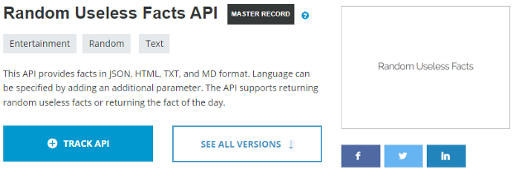

Capture by the author from Random Facts API.

You can also specify the language of the facts when using the API. In addition to that, this API allows you to get Random useless facts data and also return the fact of the day.

**7. Responsive Voice API**

With the [Responsive Voice API](https://responsivevoice.org/api/), you can convert any text to speech. This API has a lot of powerful features that you can benefit from such as changing the language, the volume, the speaker’s accent, and gender.

I highly recommend that you check out the documentation for more information on how to use the API in your next projects.

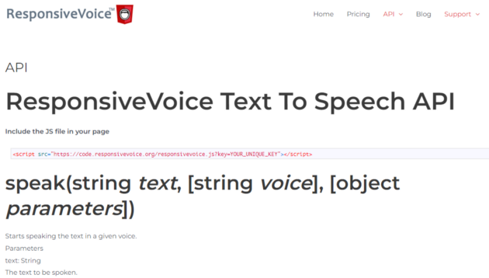

Capture by the author from Responsive Voice API.

Here is a simple example where we used the API. Check out the Codepen below:

Created by the author from [Codepen](https://codepen.io/" \t "_blank).

**8. Youtube API**

The [Youtube API](https://developers.google.com/youtube/v3" \t "_blank) gives you access to a lot of Youtube features and data that you can add to your website or application. This is useful if you are embedding Youtube videos in your projects. The API provides you with a lot of useful features.

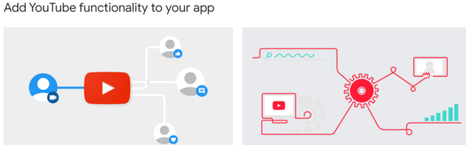

Capture by the author from Google Developers.

**9. Marvel API**

The [Marvel API](https://developer.marvel.com/) is an awesome and useful Comics API that gives developers access to a lot of information about Marvel’s library of comics. You will get access to 1000s of Marvel comics.



Capture by the author from Marvel comics API.

**10. The Count API**

The [Count API](https://countapi.xyz/) allows you to track the number of times a page has been visited and to generate numerical counters. This API may also be used to determine how frequently a button has been clicked by users for example.

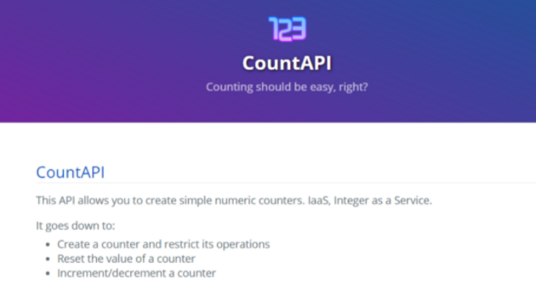

Capture by the author from the Count API.

So this API is useful and allows you to track many things in your web projects. The documentation is also simple and straightforward.

**Conclusion**

These are some of the top useful APIs that you may utilize on your projects, as you can see from the list above. They provide you with useful information that you can use as a developer. I strongly advise using APIs since they save time and make life easier.